NATIONAL DIVISIONS DIABETES PROGRAM

DIVISIONS DIABETES & CARDIOVASCULAR QUALITY IMPROVEMENT PROJECT

ANALYSIS OF DIVISION-BASED DIABETES REGISTER RECALL DATA (2000-2002)

DRAFT REPORT

Centre for General Practice Integration Studies
School of Public Health & Community Medicine
University of New South Wales
UNSW 2052

Table of Contents
1. AIMS: 1
2. INTRODUCTION 1
3. METHODS 1
3.1 Ethics approval 1
3.2 The CARDIAB register recall database 2
3.3 Invitation to participate 2
3.4 Statements of Agreement were obtained from the following: 2
3.5 Data extraction 2
3.6 De-identification of data 4
3.7 GP data 4
3.8 Patient consent 4
3.9 Ownership of data 4
4. division and general practitioner CHARACTERISTICS 5
4.1 Divisions 5
4.2 Population reach of Division register 5
4.3 GP characteristics 6
5. DATA QUALITY 8
6. DATABASE PREPARATION 9
6.1 Date of patient’s last visit to GP (CreatD). 9
6.2 Denominator issues 9
6.3 Validating the denominator 11
6.4 Transfer to SPSS 12
6.5 Cohort analysis 12
7. Quality of care and health outcome indicator targets 13
8. STATISTICAL TESTS 15
9. DESCRIPTION OF COHORT SAMPLE 16
10. APPENDIX I 21
11. APPENDIX II 24
12. APPENDIX III 25
13. APPENDIX IV 27
14. APPENDIX V NUMBER OF INCOMPLETE FIELDS AND POTENTIALLY INVALID ENTRIES LISTED BY DIVISION FOR CORRECTION AND/OR VALIDATION FOR DATA IN THE YEAR 2002 28
15. APPENDIX VI 31

AIMS:

The Divisions Diabetes & Cardiovascular Quality Improvement Project (DDCQIP) is part of the National Divisions Diabetes Program. It aims to describe both quantitatively and qualitatively, the contribution of primary care to the management of diabetes and cardiovascular disease (CVD). The project will report on the quality of care and health outcomes of people with diabetes and CVD that are managed primarily in general practice.

INTRODUCTION

The attention to improved quality of care in general practice has increased markedly in the last few years(Marshall, 2002). There are mounting demands by the public, media and politicians for greater accountability and partnership. This is hardly surprising considering that general practice is the cornerstone of Australia’s health system, visited by some 90% of Australians each year(Pegram, 2000). The emphasis on quality improvement in general practice has centred on chronic illnesses, which account for one in every ten general practice encounters (Britt, 2001).

In 2001-02 the Commonwealth National Integrated Diabetes Program aimed to improve prevention, increase early diagnosis and promote better management of diabetes, with a particular focus on general practice (National Health Priorities and Quality, 2003). Evidence provided by the UK Prospective Diabetes Study showed that good glycaemic control and management of high blood pressure can significantly improve clinical outcomes and reduce diabetes-related complications (UK Prospective Diabetes Study Group, 1998) (Stratton, 2000). Improvements in the care and outcomes of people with diabetes are associated with a systematic approach within general practice. This includes intensive follow up, use of clinical management guidelines integrated with self-management support programs. (Wagner, 1998). General practice is well placed to promote these aspects of systematic evidence based care, particularly through the use of a disease register and regular recall and review system, protected time, a practice nurse and clear written guidelines and a system for auditing standards of care (Greenhalgh, 1994, Griffin S, 1998).

Divisions of General Practice play an important role as an interface between general practice and the community. It is now generally recognised that Division activity in health promotion, illness prevention and population health can impact positively on the health outcomes of individual patients in general practice (Commonwealth Department of Health and Aged Care, 2003). Research has also shown that GPs using Division-based diabetes registers were more likely to provide patient care that adhered to evidence-based guidelines (Harris et al., 2002). The role of Divisions in promoting quality of care and population health in chronic disease areas like diabetes and cardiovascular disease is therefore of major importance.

METHODS

Ethics approval
Ethics approval for the National Divisions Diabetes Program (NDDP) Divisions Diabetes and CVD Quality Improvement Project 2002 was obtained from the University of New South Wales Human Research Ethics Committee. DDCQIP project officers signed statements agreeing to maintain the confidentiality and security of all data provided by Divisions of General Practice and upholding commitments to Divisions regarding de-identification of Division data.

The CARDIAB register recall database
CARDIAB (currently in Version 3.4) is a Microsoft Access-designed electronic database that allows general practices to register and recall diabetes and/or cardiovascular disease patients as recommended in evidence base guidelines available for diabetes management in general practice. The database contains data items that are part of the national diabetes dataset (National Health Data Committee, 2003).

CARDIAB is a Division-based system that allows register and recall of general practice patients along with the ability to generate patient summaries, and other facilities that allow user feedback. CARDIAB is used to support GP patient management, quality improvement activities and service planning and development.

Invitation to participate
In August 2002, 38 Divisions of General Practice used CARDIAB as a register-recall system. Twenty three of these Divisions had accumulated more than twelve months of data. These Divisions were invited to participate in the Divisions Diabetes and Cardiovascular Quality Improvement Project (DDCQIP).

A DDCQIP Chief Executive Officer and Division Program Officer (DPO) project kit (see Appendix I) was sent to each Division on 9 August 2002. The project kit explained the background and aims of the project. The project material also included statements from major stakeholders (DoHA, Australian Divisions of General Practice [ADGP] National Diabetes Data Working Group [NDDWG] and CVData Working Group) and outlined the conditions that they agreed to abide by:

- Participation by Divisions will be voluntary;
- Information will be used by DoHA to report on the activities of Divisions in relation to chronic disease programs and will be published as a series of reports;
- Reports will be available to a wide range of stakeholders including DoHA, Australian Institute of Health and Welfare (AIHW), ADGP, Divisions, National Diabetes Strategy Group, NDDWG, CVData Working Group, the National Health Priority Areas (NHPA) of DoHA, Diabetes Australia, the National Heart Foundation and other interested parties.

Statements of Agreement were obtained from the following:
- Health Services Division of the Department of Health and Ageing (Ms Claire Caesar, Director GP Integration Section)
- National Diabetes Data Working Group (Dr JR Flack, Chair and Secretary),
- CVData Working Group (Dr Andrew Boyden, Medical Affairs Manager, National Heart Foundation of Australia)
- Australian Divisions of General Practice Ltd (Dr Julie Thompson, Chair).

Data extraction
The research team collated the data from Divisions who use CARDIAB as their chronic disease register system. Both diabetes and cardiovascular data were collected using an electronic extraction (dump) of the data held in CARDIAB by the Division. These data will then be sent to the research team on a floppy disk by registered mail.

The electronic module was designed to extract the following data variables from each Division by year:
Site identification (de-identified)
Practice identification (de-identified)
Patient identification (de-identified)
Date of birth
Gender
Date of last patient visit to GP
Year of diagnosis
Type of diabetes (Type 1, Type 2, Gestational Diabetes Mellitus, Other, Don’t know)
Duration of diabetes
Diabetes treatment method (Diet only, Tablets, Insulin, Insulin & tablets, Nil)
Duration of insulin treatment
Tobacco smoking status
Tobacco smoking consumption
Weight
Height
Body Mass Index
Diastolic Blood Pressure
Systolic Blood Pressure
Anti-hypertensive treatment
ACE Inhibitor treatment
Ophthalmologist referral
Ophthalmologist attended
Visual retinae acuity (Left and right eyes)
Ophthalmology examination
Retinae (left and right) condition
Peripheral neuropathy
Peripheral vascular disease
Foot ulcer
Current foot ulcer
Foot deformity
Active foot lesion
Podiatry referral
Podiatry visit
Lipids fasting
Total cholesterol
Lipids HDL
Lipids LDL
Lipids triglycerides
HbA1c measurement
Micro albumin measurement
Micro albumin unit of measurement
Stroke status
Myocardial infarction
Amputation
Hypoglycaemia (severe)
Impotence
Lipid treatment
Indigenous status
Diabetes educator attended
Dietitian attended
Coronary Artery Bypass Graft
A2 Antagonists
Beta blockers
CA Antagonists
Physical activity status
Postcode
Labour status
Alcohol consumption
Year of hypertension diagnosis
Year of dyslipidaemia diagnosis

De-identification of data
The data dump conducted by the Division does not enable identification of people (GPs or patients) by the research team. Only de-identified data were transferred by the Division.

GP data
The Division stripped any GP data (and their patients’ data) from the Division database before it was transferred to the NDDP. Each Division circulated a letter (see Appendix) to participating Divisions providing them with an opt-out option.

Patient consent
Patients participating in Division chronic disease programs had already consented to their data being held by the Division for the purposes of providing a register and recall system.

Because the data being transferred to the NDDP is de-identified, it falls outside the provisions of the recent amendments to the Privacy Act (1988). However, we encouraged GPs to have their patients as fully informed as possible. For this reason, a patient information letter and waiting room notice (see Appendix) were also developed for participating GPs and practices to help inform patients about the project. The project team also provided a patient consent form suitable for use by all Divisions with chronic disease programs on its website.

Ownership of data
Divisions retained control of their identifying data at all times.. No identification of Divisions took place without written consent. Each Division was asked at the outset, for their explicit agreement to participate in the project.

division and general practitioner CHARACTERISTICS

Divisions
Twenty-two of the eligible 23 Divisions (95%) operating Division-based register recall systems (with more than 12 months data) completed an Agreement to Participate form (see Appendix) signed by the Chief Executive Officer.

Data from 16 of these Divisions were included in this analysis on the basis of the following criteria:

- Division-based register recall system had data stretching over three years
- The register recall system had to be active over each of the three years ie used to register, recall and monitor diabetes patient care.

On the basis of these criteria, 16 Divisions were included in the analysis. Eight Divisions had a RRMA classification (Prometheus Information Pty Ltd, 2002) of rural and eight had a metropolitan classification. Eleven Divisions were located in New South Wales, three in Victoria and two in Western Australia. Six Divisions had Socio Economic Index for Areas (Prometheus Information Pty Ltd, 2002). Six Divisions had ten or more percent of their population in the highest disadvantage levels of 1 and 2. Ten Divisions had less than ten percent in these groupings.

RRMA | No of Divisions
Rural | 8
Metropolitan | 8

State | No of Divisions
NSW | 11
Victoria | 3
Western Australia | 2

SEIFA | No of Divisions
Higher disadvantage | 6
Lower disadvantage | 10

Population reach of Division register
The population reach of Division registers was calculated using the Australian Bureau of Statistics (ABS) supplied Basic Community Profiles for postal areas based on place of enumeration for the 2001 Census; diabetes prevalence estimates were based on the Australian Diabetes, Obesity and Lifestyle Report 2000 (AusDiab study) and adjusted for age.

Program reach was defined as the percentage of estimated people with diabetes who are on a Division register.
- Population reach varied widely in participating Divisions across the three years 2000-2002 (see Figure 1).
- The reach of diabetes programs increased in all but one Division with an active diabetes register.
- The median reach across participating Divisions was 4.1% in 2000, 5.6% in 2001 and 10.1% in 2002.
- Program reach increased by 37% from 2000 to 2001 and by 80% from 2001 to 2002.

Figure 1: Population reach of Division diabetes program, 2000-2002, (n=16)
(Division 0 reported 57.6% in 2000, 72.3 in 2001 and 87.9 in 2002)

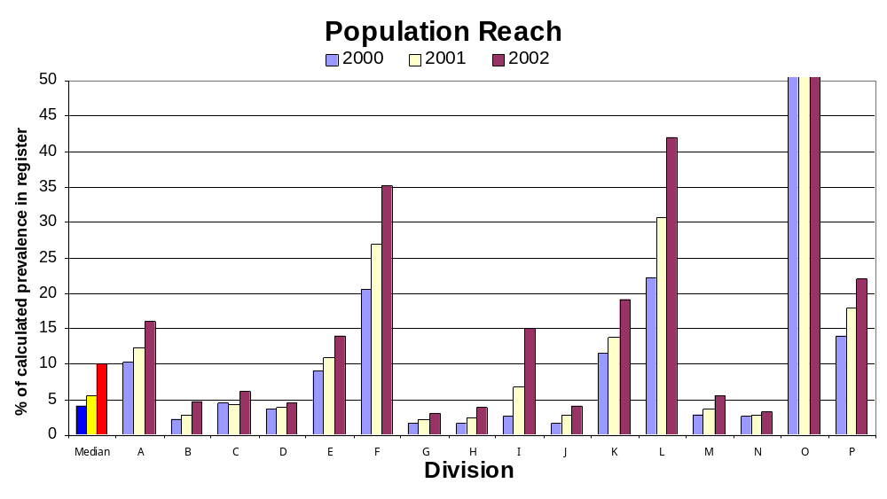

GP characteristics
All participating Divisions were asked to complete a survey entitled “Demographic characteristics of GPs: users and non-users” (see Appendix I) that asked Divisions to provide information comparing the following demographic characteristics of GPs using the Division register and those not using the register.

- Number of GPs
- Gender
- Age groups
- Practice size groups
- Work patterns (full time or part time)
- Accreditation
- Country of graduation

The proportion of Division GP users of the register (presented as a % of total GP Division population) ranged from 4.0% to 100% with a median of 39.62 and 95% confidence intervals of 17.6 – 55.0. See Figure 2 for comparison of the % of GP users by metropolitan and rural Divisions. The error bars (95%Confidence Interval) show that although rural Divisions had a greater percentage of CARDIAB users, the difference with metropolitan Divisions was not significant.

Figure 2 Error bars depicting GP CARDIAB users as a percentage of total Division population compared by RRMA

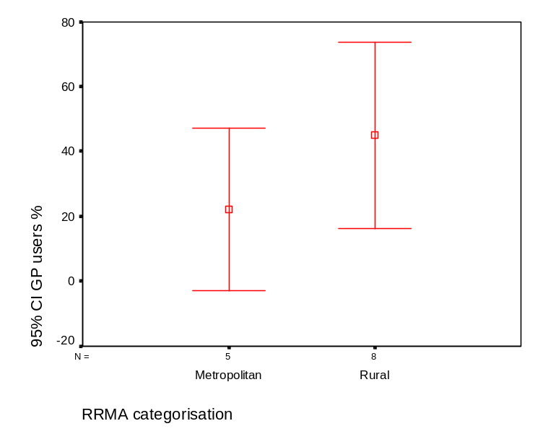

Table 1 % of GP CARDIAB users expressed as a percentage of GP population for selected demographic characteristics

Proportion of GP users and non-users as a proportion of respective total populations |  | N | Minimum | Maximum | Mean | One sample T-test
Male GPs | GP male users/total users | 13 | 55.56 | 85.71 | 70.6792 | t=.660;df=12; p=.522
Male GPs | GP male non-users/total non users | 10 | 60.00 | 80.95 | 68.9447 | t=.660;df=12; p=.522
Female GPs | GP female users/total users | 13 | 14.29 | 44.44 | 29.3208 | t=.656; df=12;p=.524
Female GPs | GP female non-users/total non-users | 10 | 19.05 | 40.00 | 31.0553 | t=.656; df=12;p=.524
Aged <35 years old | GP users (<35) % total users | 7 | .0 | 27.5 | 9.698 | t=1.278;df=6; p=.248
Aged <35 years old | GP non-users (<35) % total non-users | 4 | .0 | 13.4 | 4.524 | t=1.278;df=6; p=.248
Aged 35-44 | GP users % (35-44) of total users | 7 | .00 | 33.33 | 17.1825 | t= -4.488; df=6; p<.05
Aged 35-44 | GP non- users % (35-44) of total non-users | 4 | 17.19 | 60.00 | 36.5210 | t= -4.488; df=6; p<.05
Aged 45-54 | GP users % (45-54) of total users | 7 | 37.3 | 77.8 | 57.323 | t=4.041;df=6; p<.05
Aged 45-54 | GP users % (45-54) of total non-users | 4 | 31.3 | 40.0 | 34.041 | t=4.041;df=6; p<.05
Aged 55+ | GP % (55+) of total users | 7 | 10.0 | 25.0 | 17.177 | t=1.299; df=6; p=.242
Aged 55+ | GP % (55+) of total non-users | 4 | .0 | 27.0 | 14.136 | t=1.299; df=6; p=.242
Solo practices | GP users % solo of total users | 13 | 3.6 | 51.0 | 18.035 | t=-.498; df=12; p=.627
Solo practices | GP users % solo of total non-users | 10 | .0 | 46.3 | 19.813 | t=-.498; df=12; p=.627
Practices 2-5 | GP users % (two to four) of total users | 13 | 2.5 | 66.7 | 39.628 | t=-.44; df=12; p=.966
Practices 2-5 | GP users % (two to four) of total non-users | 10 | 18.8 | 80.0 | 39.875 | t=-.44; df=12; p=.966
Practices 5+ | GP users % (five+) of total users | 12 | 5.6 | 92.5 | 32.641 | t=-.880; df=11; p=.398
Practices 5+ | GP users % (five+) of total non-users | 9 | .0 | 58.5 | 38.571 | t=-.880; df=11; p=.398
Full time | GP full time GP users % of total users | 10 | 75.0 | 98.0 | 85.976 | t=4.278; df=9; p<.005
Full time | GP full time GP users % of total non-users | 9 | 53.0 | 90.2 | 74.349 | t=4.278; df=9; p<.005
Part time | GP users (part time) % of total users | 10 | 3.9 | 25.0 | 12.431 | t=-5.711; df=9; p<.0005
Part time | GP users (part time) % of total non-users | 9 | 14.3 | 53.0 | 26.994 | t=-5.711; df=9; p<.0005
Accredited | GP users (accredited) % of total users | 11 | 39.53 | 100.00 | 76.4094 | t=1.990; df=10; p=.075
Accredited | GP non-users (accredited) % of total non-users | 9 | 12.54 | 100.00 | 61.6723 | t=1.990; df=10; p=.075
Country of graduation | GP users (graduated outside Australia) % of total users | 6 | 4.76 | 35.00 | 18.1925 | t=.247; df=5; p=.815
Country of graduation | GP non-users (graduated outside Australia) % of total non-users | 5 | 1.56 | 26.83 | 17.1756 | t=.247; df=5; p=.815

Table 3 compares the GP CARDIAB users expressed as a percentage of total users for the demographic characteristics of gender, age, practice size, accreditation and country of gradation. The means for users and non-users were then tested for any significant differences using the One sample t-test (Argyrous, 2001). These tests showed that there was a significant percentage more full time users of CARDIAB than part time, and that they appeared more frequently in the 45-54 age bracket and less frequently in the 35-44 age bracket.

DATA QUALITY

A data cleaning process was generated by the Bankstown Diabetes Centre. This process identified all missing data fields along with potentially invalid data values for Divisions to check. This process identified particularly high or low HbA1c, high HDL cholesterol, or low Triglyceride levels or missing data using the following template:

[1] Male = Pregnant
[2] Female < 15 or > 50 = Pregnant
[3] Type 1 and Rx = Diet or Tablets
[4] GDM and Rx = Tablets OR GDM and not Pregnant OR GDM Duration >1 year
- Pregnant male
- Age <15 or >50 with GDM or pregnant
- GDM but not pregnant
- GDM duration > one year
[5] Year of Diagnosis < Date of Birth OR On Insulin Since Year < Date of Birth
[6] On Insulin Since Year < Date of Diagnosis
[7] Age < 2 at Diagnosis
[8] Age < 20 and on Antihypertensive
[9] Diastolic BP is > Systolic BP or Systolic <70 or >220 or Diastolic <40 or >130
[10] Age >14 and Height < 1.3 Metres or > 2.0 Metres
[11] Age >14 and Weight < 40 Kilograms or > 150 Kilograms OR Age >14 with BMI <15
[12] Type 1 and On Insulin Since Year >= 3 years after Date of Diagnosis
[13] HbA1c >20 or <3.5
[14] Total cholesterol >30 or <2
[15] HDL cholesterol >2.5 or <0.5
[16] Triglycerides >50 or <0.5

Table 2 lists the numbers, percentage and Division median of incomplete fields and potentially invalid fields that were identified for the year 2002, and forwarded to Divisions for validation and/or correction where possible. A complete list by Division is provided in Appendix V.

Table 2 Total number potential errors and incomplete fields based on output sent to Divisions for correction and/or validation (n=13,325)

Item (incomplete or potentially invalid) | Total | % of total
Date of birth | 233 | 1.75
Diagnosis | 2651 | 19.89
Diabetes type | 1082 | 8.12
Management method | 2788 | 20.92
Date beginning of insulin treatment | 4310 | 32.35
Weight | 4219 | 31.66
Height | 4953 | 37.17
Treatment method | 159 | 1.19
Pregnant | 335 | 2.51
Age and diagnosis date | 45 | 0.34
Date of birth/diagnosis date | 49 | 0.37
Year of diagnosis/insulin date | 9 | 0.07
Height/Weight/Body Mass Index | 90 | 0.68
Anti-hypertensives and Age | 1 | 0.01
Blood pressure | 28 | 0.21
Female/Erectile disorders | 10 | 0.08
Cholesterol | 10 | 0.08
Triglycerides | 24 | 0.18
HDL | 86 | 0.65

DATABASE PREPARATION

Date of patient’s last visit to GP (CreatD).
The CreatD field in CARDIAB is the date of review for each patient. It is based on the last date in the given year that the patient was seen by a GP. The CARDIAB extraction reports contain up to 1200 entries (spread over three years) where no CreatD is showing but with some results eg pathology tests, BP, Weight, Height, etc. This error occurs across all Divisions.

Intouch Consultancy (the database programming company responsible for the assembly of the CARDIAB database) advised that this represents those situations where test results come in sometime after the GP visit, and into a new financial year (annual cycle). For example, a patient may see the doctor on 1 June but the results are not entered until July or August of the new (financial) year. This issue allowed the possibility that the quality of care indicators for each of the years may be underestimated.

The issue is complicated by the fact that we cannot identify if the problem is due solely to lag time (between GP review and test results), or whether it may be due to CreatD not being entered, which was once possible in CARDIAB, but no longer is.

The Bankstown Diabetes Centre responsible for preparing the database were instructed to accept these records as valid data, which means the assessments will be counted in the year that the results came through.

Denominator issues
The initial analysis of data from the complete CARDIAB extraction of all 22 Divisions over the years 2000-2002 was performed in early September 2003 by the Bankstown Diabetes Centre.

One of the validation checks undertaken was to compare the percentages achieved for various quality of care indicators (eg HbA1c and BP etc) for Divisions that were also involved in both the 1999 collation project and the current DDCQIP study. Our initial checks among two Divisions found that the percentages had decreased markedly from the earlier study.

The next step was to ask the Divisions to look over the DDCQIP figures and check whether they conformed with their own. One Division went back over the figures and even searched through historical reports dating back two years. They found major discrepancies between the denominator used in the DDCQIP analysis and that provided in their audit reports.

The research team then contacted InTouch Consultancy to undertake an interrogation of the data extraction program that each participating Division had used to provide data for the study.

Intouch Consultancy established that the data extraction for each Division was used to pick up every active patient on the database as of the date of the extraction (>30 June 2002). Each patient was then placed into each year (2000, 2001 or 2002) with a field called CreatD added to indicate the last date (in each specified year) that an assessment was carried out. What was missing from this extraction was a check to confirm that patients were actually enrolled in the program for the designated year.

What this means is that patients that entered the program in 2002 are now appearing in the files for 2001 and 2000 also. This resulted in an inflated denominator for each year.

In order to correct this problem the research team outlined the steps outlined below and carried out with the Bankstown Diabetes Centre using Access 2000 software.

- In the raw data we noticed a number of patient records with a negative figure in the field Duration of diabetes. These data were treated as invalid values and put it down to incorrect data entry. But it now appears that these data were a result of patient records being placed in a year prior to their entry onto the program. For example, a patient with a value of –1 was diagnosed in 2001 but incorrectly appears in the 2000 database.
- By flagging all the negative Duration of diabetes (and null values in CreatD) values we would still only dealt with a small proportion of the problem. This is because a) not all patient records have a recorded Date of diagnosis field which is used to calculate Duration, and there are many patients who may have become part of the program in 2002 but had diabetes diagnosed prior to 2000, in which case it would appear as a valid value in the field.
The problem could then be visualised using the following matrix where X represents a valid CreatD with data and 0 represents a potentially invalid set of data:
 | 2000 | 2001 | 2002
A | X | X | X
B | O | X | X
C | O | O | X
D | X | X | O
E | X | O | O
F | O | X | O
G | O | O | O

The shaded cells represent data that we could consider deleting with varying degrees of confidence.

- Deleting row G completely across all three years: This would be a fairly reliable option as if there was no assessment in any of the three years the patient would likely have joined the program after the time period we are interested in.
- Intuitively it would also seem that Option C is also valid.
- The choice then of deleting any of the other cells is problematic.

The results of the tests across the whole database are presented below:

TEST | 2000 | 2001 | 2002
Existing total | 19613 | 19065 | 18497
Test 1  Flag all records with null CreatD & with a value of <0 in Duration of Diabetes and have no Quality of Care variable values | 2493 | 933 | 4
Test 2  Flag all records that have a null CreatD for 2000 and 2001 and 2002 and have no Quality of Care variable values | 4191 | 4191 | 4191
Test 3  The combined effect of test 1 and 2  (figures in brackets are duplicate values) | 5938  (746) | 4378  (746) | 4192
Test 4  Flag all records that have a null CreatD for 2000 and 2001 and have no Quality of Care variable values  (figures in brackets are duplicate values) | 7521  (4551) | 7521  (3684)
Test 5  The combined effect of test 1 and 2 and 3  (t1 + t2 +t4) – (t4 duplicates) | 9654 | 8781 | 4192

Validating the denominator
The figures from the validation procedures presented above were then compared with those provided by the Divisions in a survey they completed in 2002 as part of their participation in the project (see Appendix VI) This allowed us to ensure that our final denominator total for each Division for each year equaled that provided by the Division.

In most cases this procedure worked without any problems. However in the case of three Divisions in 2000 (Division H, B and D) and three Divisions in 2001 (Division I, C and H) there procedures would have resulted in the loss of cases with actual assessment values.

We decided that we would not delete any cases, which had values in them. This meant that the Divisions listed above had slightly different denominators from the audit data they provided us in 2002. The difference was in the vicinity of 1% to 3%. The numerator did not change.

As a further validation, we sent each Division a set of figures containing numerator and denominator data to check that the numbers accorded with their own audit reports from the time. Eleven Divisions responded. Nine of these Divisions confirmed that the figures corresponded with their own. One Division was unable to verify the figures.

The data from one Division did not correspond exactly with a current audit report, however it was not clear if these differences were the product of patients made inactive since the data extraction (nearly a year ago) or because the current CARDIAB version 3 audit report is dysfunctional. We decided to accept the validation figures originally provided by the Division.

Transfer to SPSS
The Bankstown Diabetes Centre used Access software to arrange CARDIAB data over each of the three years into one database allowing analysis of paired data over time. Data was verified used the unique de-identified number for each entry.

All data was flagged using the variables Vis_2000, Vis_2001 and Vis_2002 to identify patients who had visited a GP in any of the respective years. A visit to a GP was defined as any CreatD entry in the given year or an entry in a given year into any one of the quality of care items: Total cholesterol, triglycerides, HDL, LDL, Blood Pressure, BMI, Microalbumin.

Cohort analysis
A cohort sample was then identified and flagged using the variable Cohort1. The sample was made up of all patients who had recorded a visit in 2000, 2001 and 2002. This required an entry into each of the variables: Vis_2000, Vis_2001 and Vis_2002.

The flagged cohort database consisted of the following summarised data:

The number of patients in the cohort is 3002.
The cohort is made up of 16 Divisions each with a functioning register system over the period 2000-2002.
- Patients analysed in the cohort had to have seen a GP at least once in each of the three years 2000, 2001 and 2002.
- Six Divisions were excluded from the analysis. Of these six Divisions three (291, 709, 965) did not have a functioning register across each of the three years and three (612, 654, 761) Divisions had a register that had deteriorated in the course of the 3 years.
- The number of cases in the cohort was compared with estimated diabetes prevalence and percentage provided for each Division.
- The mean across the 16 Divisions was 3.48% and the median was 2.15%.

Division ID | N of cases in cohort study | % in cohort study | Estimated diabetes prevalence | Cohort number % of estimated prevalence
42 | 233 | 7.8 | 2657 | 8.77
54 | 551 | 18.4 | 8057 | 6.84
201 | 340 | 11.3 | 9853 | 3.45
248 | 278 | 9.3 | 3889 | 7.15
263 | 20 | .7 | 4930 | 0.41
351 | 35 | 1.2 | 10978 | 0.32
358 | 430 | 14.3 | 9360 | 4.59
407 | 84 | 2.8 | 5747 | 1.46
409 | 197 | 6.6 | 9162 | 2.15
427 | 79 | 2.6 | 10164 | 0.78
469 | 116 | 3.9 | 13697 | 0.85
564 | 69 | 2.3 | 11788 | 0.59
703 | 124 | 4.1 | 1466 | 8.46
704 | 35 | 1.2 | 6585 | 0.53
862 | 95 | 3.2 | 14389 | 0.66
985 | 316 | 10.5 | 3634 | 8.70
Total | 3002 | 100.0
 |  |  | Median | 2.15
 |  |  | Mean | 3.48

Quality of care and health outcome indicator targets

The following guidelines were reviewed to determine the appropriate target for health outcome indicator reporting:

- Royal Australian College of General Practitioners guidelines “Diabetes in General Practice”
- NHMRC Evidence based guidelines
- National Heart Foundation guidelines
- NSW Health Principles 1996

Changes in guideline targets for people with diabetes over time (1999/2000 – 2002)

 | 2000 |  |  | 2001 |  |  | 2002
 | RACGP | NSWHealth | NHF | RACGP | NHMRC | NHF | RACGP | NHMRC | NHF
Lipids
Total chol | < 5.0 | < 5.5 | < 4.5 | < 5.0 |  | < 4.0 | < 4.0 |  | < 4.0
Triglycerides |  | < 2.0 | < 2.0 |  |  | < 2.0 | < 2.0 |  | < 2.0
HDL | >= 1.0 | > 1.0 | > 1.0 | >= 1.0 |  | > 1.0 | >= 1.0 |  | > 1.0
LDL | < 3.0 |  | <= 3.5 | < 3.0 |  | < 2.5 | < 2.5 |  | < 2.5
Blood pressure | 130/85 | <140/90  age dependent | < 130/85 | < 130/85 | < 130/85  <125/75 if proteinuria > 1g/day | < 130/85 | < 130/85 | <130/85  <125/75 if proteinuria > 1g/day | < 130/85
BMI
BMI normal | <= 25 | < 25 | < 25 | <= 25 | <= 25 |  | <= 25 | <= 25 | < 25
Overweight |  |  | 25-30 |  | 25-29.9 |  |  | 25-29.9 | 25-30
Obese |  |  | > 30 |  | >30 |  |  | >= 30 | 30
Microalbumin
 | Timed | ACR fem | ACR male
Normal | < 20ug/min | 0-3.5 | 0-2.5
Microalb | 20-200 ug/min | 3.6-30 | 2.6-30
Macroalb | > 200 ug/min | >30 | >30

The following table outlines the values chosen as indicators for data analysis:

INDICATOR | NORMAL | ABNORMAL – 1 | ABNORMAL – 2
Body Mass Index | <=25 | >25 <30 | >= 30
Blood Pressure | <85 diastolic  <130 systolic | >= 85 diastolic  >= 130 systolic
Total cholesterol | <5 | >=5
HDL | >=1 | <1
LDL | <3 | >=3
Triglycerides | < 2 | >= 2
HbA1c  HbA1c – High HbA1c | <= 1% upper limit of normal | > 1 <= 2 % upper limit of normal | > 2 upper limit of normal
Microalbumin  Microalbumin unit 2 = timed  Microalbumin unit 4 = ACR | Timed  <20  Male Female  <=2.5 <= 3.5 | Timed  >=20 < 200  Male Female  >2.5 > 3.5 <= 30 | Timed  >= 200  Male Female  >30 >30

The variables were then calculated according the categories:

0 = Normal
1 = Abnormal
2 = Abnormal
9 = No check

The following table describes the method used for recoding the data:

Variable | Method of categorising
Body Mass Index  BMI | If the BMI field is empty, then BMI Gr = 9  otherwise, if BMI > 25 (and <30) then BMI Gr = 1  otherwise, if BMI >= 30 then BMI Gr = 2  otherwise, if BMI <= 25 then BMI Gr =0
Blood pressure  Diast BP, SystolBP | If Systolic BP field is empty, then BP Gr = 9  otherwise, if either Diastolic BP >= 85, or Systolic BP >= 130 then BP Gr = 1  otherwise, BP Gr = 0
Eyes  RetinaeR, RetinaeL | If the RetinaL and RetinaR fields are empty, then Retina-Abonormal = 9  otherwise, if either RetinaR or RetinaL = 3 , then Retina-Abnormal = 1  otherwise, Retina-Abnormal = 0
Feet  PeriphNeur, PeriphVas, PHUlcerat, Ulcerat, FtDefDrm, ActFtLes | If all of PeriphNeur, PeriphVas, PHUlcerat, Ulcerat, FtDefDrm and ActFtLes have no values, then Feet = 9  otherwise, if any of the above fields = 1 then Feet =1  otherwise, Feet = 0
Cholesterol  LipChol | If LipChol field is empty, then Chol Gr = 9  otherwise, if LipChol >= 5 then Chol Gr = 1  otherwise, Chol Gr = 0
HDL  LipHDL | If the LipHDL field is empty, then HDL Gr = 9  otherwise, if LipHDL < 1 then HDL Gr = 1  otherwise, HDL Gr = 0
LDL  LipLDL | If the LipLDL field is empty, then LDL Gr = 9  otherwise, if LipLDL < 3 then LDL Gr = 0  otherwise, LDL Gr = 1
Tglyc Gr  LipTglyc | If the LipTglyc field is empty, then Tglyc Gr = 9  otherwise, if LipTglyc >= 2 then Tglyc Gr = 1  otherwise, Tglyc Gr = 0
HbA1c  HbA1c, HigHbA1c | If the HbA1c field is empty, then HbA1c Gr = 9  otherwise, if HbA1c - Hig HbA1c > 2 then HbA1c Gr = 2  otherwise, if HbA1c - Hig HbA1c > 1 (and <= 2) then HbA1c Gr = 1  otherwise (if number is <=1), HbA1c Gr = 0
Microalbumin  uAlbumin, uAlbUnit, Sex | If the uAlbumin field is empty, then uAlb Gr = 9  otherwise,  If uAlbUnit = ug/min then (TIMED)  If uAlbumin >= 200 , then uAlb Gr = 2  otherwise, if uAlbumin >= 20 (and < 200) , then uAlb Gr = 1  otherwise, uAlb Gr = 0  otherwise, IF uAlbUnit = mg/L then (SPOT)  If uAlbumin <30 , then uAlb Gr = 0  otherwise, if uAlbumin > 300 then uAlb Gr = 2  otherwise, uAlb Gr = 1  otherwise (if uAlbUnit = Ratio) (RATIO)  If Sex = 1 ( Male ) then  If uAlbumin > 30 , then uAlb Gr = 2  otherwise uAlbumin > 2.5 (and <= 30) , then uAlb Gr = 1  otherwise uAlb Gr = 0  otherwise ( if sex = 2 (female)) then  If uAlbumin > 30 , then uAlb Gr = 2  otherwise uAlbumin > 3.5 (and <= 30), then uAlb Gr = 1  otherwise uAlb Gr = 0

STATISTICAL TESTS

SPSS version 11 was used to examine the data. The following statistical definitions and tests (Brace, 2003) were used:

Chi-square: an inferential statistical test that is used to analyse frequencies of nominal data, allowing comparisons between the observed frequencies in the data and the frequencies that would be expected by chance.

Correlation: a term used to describe a linear relationship or association between two variables.

Degrees of freedom: a number related to the number of participants who took part in the study or the number of factors (or independent variables) in the study.

Error bar graph: a graph in which the mean of each condition is plotted with a vertical bar that denotes the 95% confidence interval.

Independent t-test: a parametric test used to determine whether two means are significantly different from one another. There are three types of t-tests: single sample t-test, independent t-test and paired sample t-test.

Multiple regression: an inferential statistical procedure used to investigate linear relationships between three or more variables.

McNemar test: used to analyse data obtained by a measuring a dichotomous variable.

Parametric and nonparametric: terms that denote the level of measurement (nominal or ordinal for nonparametric; ratio or interval for parametric). The terms also denote ratio or interval scales that do not meet the assumptions (normality of distribution) underlying parametric tests.

Significance level: the level of probability (p) that the results are due to chance, at which the null hypothesis is rejected. By convention the p value must be less than or equal to .05.

DESCRIPTION OF COHORT SAMPLE

Frequency counts  - The number of patients in the cohort is 3002. The cohort is made up of 16 Divisions each with a functioning register system over the period 2000-2002.  - Patients analysed in the cohort had to have seen a GP at least once in each of the three years 2000, 2001 and 2002.  - Six Divisions were excluded from the analysis. Of these six Divisions three (291, 709, 965) did not have a functioning register across each of the three years and three (612, 654, 761) Divisions had a register that had deteriorated in the course of the 3 years.  - The number of cases in the cohort was compared with estimated diabetes prevalence and percentage provided for each Division.  - The mean across the 16 Divisions was 3.48% and the median was 2.15%. | No of cases by Division
  Division ID | N of cases in cohort study | % in cohort study | Estimated diabetes prevalence | Cohort number % of estimated prevalence
  42 | 233 | 7.8 | 2657 | 8.77
  54 | 551 | 18.4 | 8057 | 6.84
  201 | 340 | 11.3 | 9853 | 3.45
  248 | 278 | 9.3 | 3889 | 7.15
  263 | 20 | .7 | 4930 | 0.41
  351 | 35 | 1.2 | 10978 | 0.32
  358 | 430 | 14.3 | 9360 | 4.59
  407 | 84 | 2.8 | 5747 | 1.46
  409 | 197 | 6.6 | 9162 | 2.15
  427 | 79 | 2.6 | 10164 | 0.78
  469 | 116 | 3.9 | 13697 | 0.85
  564 | 69 | 2.3 | 11788 | 0.59
  703 | 124 | 4.1 | 1466 | 8.46
  704 | 35 | 1.2 | 6585 | 0.53
  862 | 95 | 3.2 | 14389 | 0.66
  985 | 316 | 10.5 | 3634 | 8.70
  Total | 3002 | 100.0
   |  |  | Median | 2.15
   |  |  | Mean | 3.48
Age breakdown across the cohort  The percentages in the cohort study by age group were compared with AusDiab estimates of the 2001Australian population. The cohort study had proportionately more patients in the 55-64 and 65-74 age groups and less in the 35-44, 45-54 and 75+ age groups. | 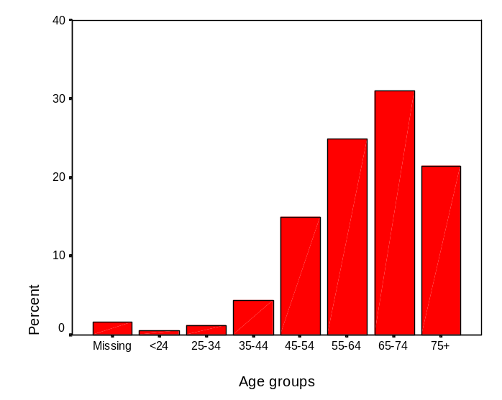
   |  | Frequency | Percent | Ausdiab
  Valid | <24 | 16 | .5
   | 25-34 | 36 | 1.2 | 0.85
   | 35-44 | 131 | 4.4 | 7.43
   | 45-54 | 449 | 15.0 | 16.5
   | 55-64 | 747 | 24.9 | 23.88
   | 65-74 | 931 | 31.0 | 24.67
   | 75+ | 646 | 21.5 | 26.67
   | Total | 2956 | 98.5
  Missing | System | 46 | 1.5
  Total |  | 3002 | 100.0 | 100.0
 | 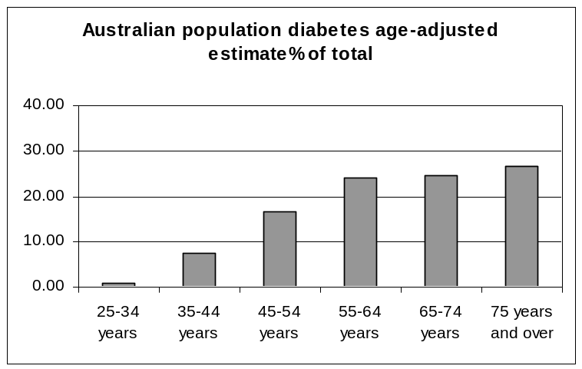
  Age adjusted prevalence of diabetes (25 years and over) in Australia using AusDiab (Australian Diabetes Obesity and Lifestyle Study (AusDiab), 2001) figures.
   | Male | Female | Total | Prevalence estimate | % of total
  0-4 years | 638084 | 605862 | 1243946
  5-14 years | 1369867 | 1298634 | 2668501
  15-24 years | 1305878 | 1260457 | 2566335
  25-34 years | 1341163 | 1382367 | 2723530 | 8171 | 0.85
  35-44 years | 1408604 | 1459651 | 2868255 | 71706 | 7.43
  45-54 years | 1275786 | 1292429 | 2568215 | 159229 | 16.5
  55-64 years | 884498 | 875095 | 1759593 | 230507 | 23.88
  65-74 years | 615382 | 664680 | 1280062 | 238092 | 24.67
  75 years and over | 427216 | 663490 | 1090706 | 257407 | 26.67
   | 9266478 | 9502665 | 18769143 | 965111
Comparisons with BEACH data based on GP encounters (Senes, 2001)The BEACH study reported 209 cases of diabetes Type 1 and 2264 cases of Type 2. BEACH figures by age group were compared with the data from the cohort study according to BEACH age brackets as presented below: | 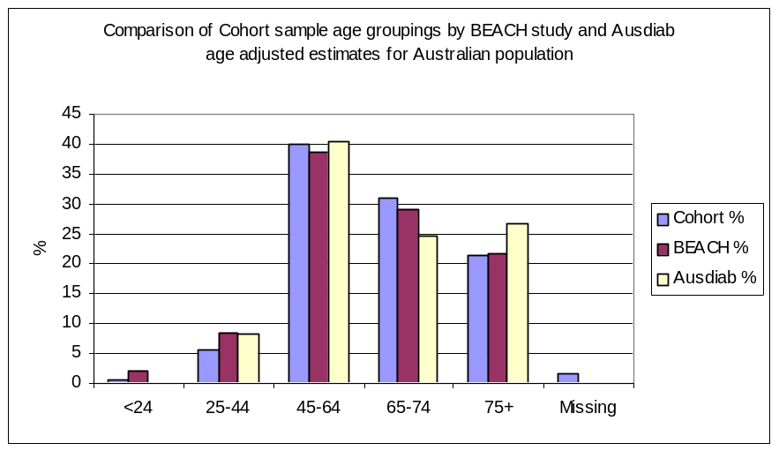
   | Cohort study (n=3002) | BEACH (n=2471) | AusDiab
  <24 | 0.5 | 2.1
  25.-4 | 5.6 | 8.6 | 8.3
  45-65 | 39.9 | 38.7 | 40.4
  65-74 | 31.0 | 29.1 | 24.7
  75+ | 21.5 | 21.6 | 26.7
  Missing data | 1.5
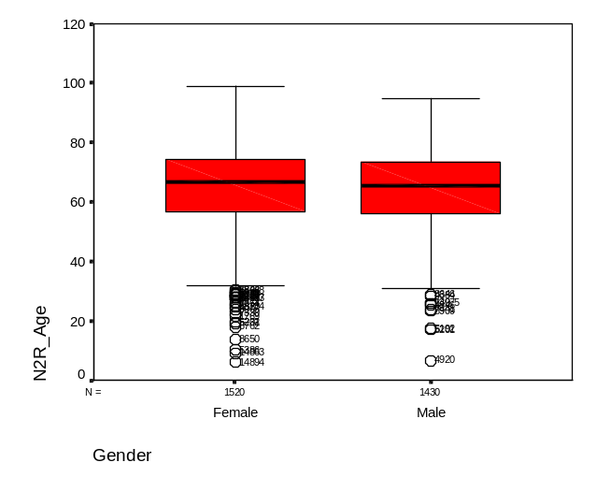 | Comparison by age & gender  - 51.3% (1541) were female  - 48.5% (1455) were male  - 0.2% (6) gender not specified  - Female mean age 65.17 (CI: 64.51-65.82)  - Male mean age 64.36 (CI: 63.73-64.98)  BEACH reported 47.5% females and 52.5% males in their GP encounter sample of Type 1 and Type 2 diabetes patients.
Comparison by diabetes type  - There were 2731 Type 2 patients and 237 Type 1 patients. There was a small number of other (GDM and don’t know) cases) and 29 missing cases.  - The table below shows that there were not any significant differences between diabetes type and gender. Chi square = 1.112; df=1 p=.292  Type of diabetes 2002 by gender | Diabetes type
   |  |  |  |  | Total
   |  |  | Female | Male
  Type of diabetes 2002 | Type 1 | Count | 130 | 107 | 237
   |  | % within N2R_Gender | 8.5% | 7.5% | 8.0%
   | Type 2 | Count | 1398 | 1328 | 2726
   |  | % within N2R_Gender | 91.5% | 92.5% | 92.0%
  Total |  | Count | 1528 | 1435 | 2963
   |  | % within N2R_Gender | 100.0% | 100.0% | 100.0%
   |  | Frequency | Percent | Valid Percent | Cumulative Percent
  Valid | Type 1 | 237 | 7.9 | 8.0 | 8.0
   | Type 2 | 2731 | 91.0 | 91.9 | 99.8
   | GDM | 3 | .1 | .1 | 99.9
   | Other | 1 | .0 | .0 | 100.0
   | Don't Know | 1 | .0 | .0 | 100.0
   | Total | 2973 | 99.0 | 100.0
  Missing | System | 29 | 1.0
  Total |  | 3002 | 100.0
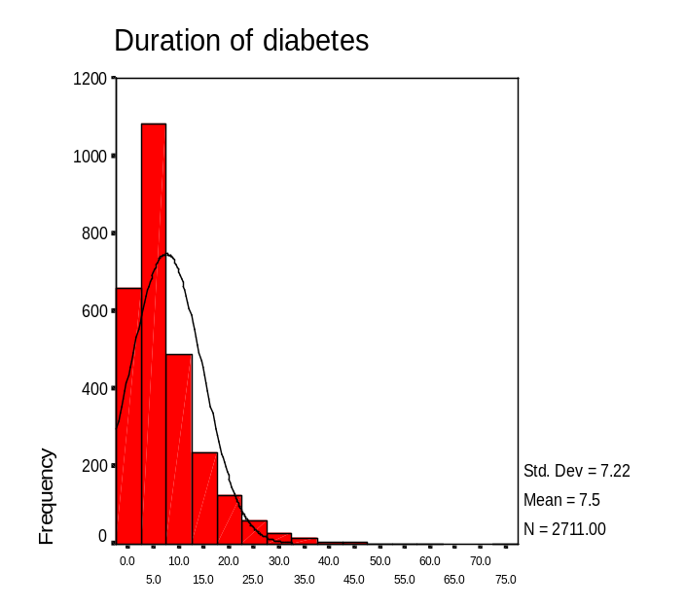 | Duration of diabetes  There was no significant difference in diabetes duration based on gender.  Whole sample (n=2711) M =7.49; Md 5.00; 95%CI: 7.22 – 7.76  Females M = 7.61 Md = 5.00; 95%CI: 7.23 – 7.99  Males M = 7.35 Md = 5.00; 95%CI: 6.96 – 7.74  Type 1 M = 17.0 Md= 15.0; 95%CI: 15.35 – 18.64  Type 2 M = 6.74 Md = 5.0; 95%CI: 6.50 – 6.98
Duration of diabetes (categories) by gender as of 2000  The duration of diabetes was recoded according to ANDIAB duration categories (0, 1-5, 6-10, 11-15, 16+). There was a fairly even gender spread across each of the categories. | 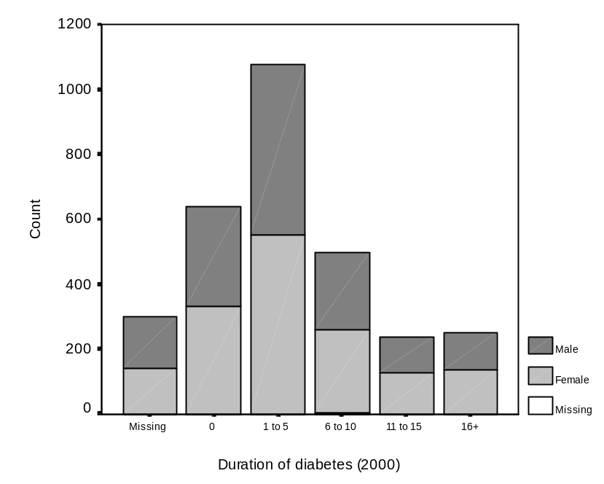

APPENDIX I

Dear

DIVISIONS DIABETES & CVD QUALITY IMPROVEMENT PROJECT 2002

I am writing to invite you to participate in the National Divisions Diabetes Program (NDDP) Divisions Diabetes & CVD Quality Improvement Project (DDCQIP). The Department of Health and Ageing (DoHA) is interested in providing the opportunity for Divisions to present the important work they have done in national health priority areas and to share it with their colleagues in other Divisions, in general practice, across the health sector and in the wider community.

To this end, the DoHA has engaged the NDDP to seek information from Divisions about their chronic disease programs.

If you choose to participate in the project your information will be used to produce a report entitled “Divisions of General Practice Profiles – Chronic Disease (Diabetes & CVD) Programs” which will be published in 2003.

The report does not require collection of new data – it is a retrospective study and the results will be based on information you already have about the chronic disease programs in your Division.

The profiles produced will have two sections. Section A will contain descriptive information about each Division and its chronic disease programs as supplied by the Divisions themselves. It will also contain demographic data from the 2000 census and estimates of the population in the area with chronic illness.

Divisions that use CARDIAB as their register recall system and have more than 12 months of data will be invited to complete Section B. This will contain information about GP and patient participation rates in programs, quality of care and health outcomes. These data will be de-identified but coded, so that each Division will know which data is their own. We will also ask for some information about the characteristics (age, gender and type of practice) between those GPs using CARDIAB and the whole Divisional GP population. This information will allow us to identify any major differences. Section B will contain summary comparative charts and this data will also be de-identified and coded. This information will be published as a separate volume to section A so that identification of Divisions is not possible.

A conference to present the results of the study will be held in 2003 which you will be invited to attend. Quality improvement workshops will also be conducted with Divisions who provide quality of care and health outcomes data to assist them with review, planning and changes to their Division programs.

In consideration of some major issues regarding Division participation and use of data, the DoHA and the Australian Divisions of General Practice (ADGP) have agreed to abide by the following conditions:

- participation by Divisions will be voluntary;
- the information will be used by DoHA to report on the activities of Divisions in relation to chronic disease programs and will be published as a series of reports;
- the reports will be available to a wide range of stakeholders including DoHA, AIHW, ADGP, Divisions, the National Diabetes Strategy Group, the National Diabetes Data Working Group (NDDWG), the CVData Working Group, the National Health Priority Areas (NHPA) of DoHA, Diabetes Australia, the National Heart Foundation and other interested parties.

Data extraction
The NDDP will be collating data from Divisions who use CARDIAB as their chronic disease register system, and who have more than 12 months data. Both diabetes and cardiovascular data will be collected from Divisions with these programs. This will involve an electronic extraction (dump) of the data held in CARDIAB by the Division. These data will then be sent to the NDDP on a floppy disk by registered mail.

De-identification of data
The data dump conducted by the Division does not enable identification of people (GPs or patients) by the NDDP. Only de-identified data are transferred to the NDDP by the Division.

GP data
However, if GPs do not want to participate in the project at all, the Division can strip all their data (and their patients’ data) from the Division database before it is transferred to the NDDP. To assist with this, we have drawn up a letter for Divisions to circulate to GPs informing them of this option.

Patient consent
Patients participating in Division chronic disease programs have already consented to their data being held by the Division for the purposes of providing a register and recall system. These data are used for clinical audit to assist GPs provide best practice care to their patients. The Divisions Diabetes & CVD Quality Improvement Project (DDCQIP) provides valuable information to Divisions to assist them in their role of practice support by providing program quality improvement information.

Because the data being transferred to the NDDP is de-identified, it falls outside the provisions of the recent amendments to the Privacy Act (1988). However, we encourage and support GPs to have their patients as fully informed as possible. For this reason, a patient information letter and waiting room notice have also been developed for participating GPs and practices to help inform patients about the project. The NDDP also provides a patient consent form suitable for use by all Divisions with chronic disease programs on its website. A copy is included in the kit.

Use of the data
The data generated will be used to report nationally on the success of chronic disease management programs run by Divisions of General Practice and the important contribution of general practice to the management of chronic disease in the community. The data will also be used by the NDDP to conduct quality improvement activities with Divisions to assist them with peer review of their programs, program evaluation, service planning and delivery. Each Division's data will be provided back to them both in hard copy and electronically for their own use.

Ownership of data
Divisions will at all times retain control of their identifying data. No identification of Divisions will take place without their written consent. For this reason, we ask Divisions at the outset, for their explicit agreement to participate in the project. We also ask if they will agree to be identified only to other participating Divisions at the end of the project so that they may attend the quality improvement workshops with other Divisions enabling comparisons to be made between programs.

Attached are:
- copies of the statements of agreement outlining the undertakings of DoHA, ADGP, NDDWG and CVData Working Group
- the Chronic Diseases Programs Division profile survey and GP characteristics survey that we would like your Division to complete
- examples from the 1999 Data Collation Project of the types of graphs that will be produced in the reports
- samples of the form letter for members, the ‘opt-off’ faxback for members and the waiting room sign

Please confirm your intention to participate or decline by completing and returning both of the attached faxback forms within the next 7 days. If we do not hear from you we will contact you again.

The return date for the Division Profile is 20 September 2002.

If you choose to participate in the project, a member of the project team will contact your Diabetes and/or CVD Program Officer to assist with the CARDIAB data extraction.

If you have any questions regarding the project you can contact any of the project team:

Joan Burns
(NDDP Program Manager) Tel: (02) 9385 1507 Email: j.burns@unsw.edu.au
Danielle Penn
(CARDIAB/CVD Project Officer) Tel: (02) 9385 1449 Email: d.penn@unsw.edu.au
Andrew Georgiou
(DDCQIP Project Officer) Tel: (02) 9385 1509 Email: a.georgiou@unsw.edu.au

The CARDIAB data collation will provide an opportunity for Divisions to aggregate and compare their de-identified CARDIAB data with that of other Divisions and to engage in program peer review and quality improvement. Your participation in this initiative is encouraged as it will showcase the work of Divisions with chronic disease programs and demonstrate the important contribution of general practice in this important area.

Yours sincerely,

Professor Mark Harris
Professor of General Practice
School of Public Health and Community Medicine

If you have any complaints about the way this research has been conducted please contact Mrs M Wright, Ethics Secretariat, University of New South Wales, Randwick, NSW 2052 m.wright@unsw.edu.au

/tmp/lo/0000.doc Sunday, 8 November 2026

APPENDIX II

DIVISIONS DIABETES & CVD QUALITY IMPROVEMENT PROJECT 2002

AGREEMENT TO PARTICIPATE – Section B

❑ | I agree to the Division participating in Section B (CARDIAB) of the Divisions Diabetes & CVD Quality Improvement Project
❑ | I do not agree to the Division participating in Section B (CARDIAB) of the Divisions Diabetes & CVD Quality Improvement Project

The Division will submit quality of care and health outcomes data for the programs:

❑ | Diabetes
❑ | Cardiovascular disease

I understand that the information supplied will be provided to the National Divisions Diabetes Program (NDDP) at the Centre for GP Integration Studies and will be used to produce a series of reports entitled “Divisions of General Practice Profiles – Chronic Disease (Diabetes and CVD) Programs”.

I understand that the descriptive information in Section A will be Division-identified program descriptive information. Data supplied by the Division for Section B on quality of care and health outcomes will be de-identified. No GP, patient or Division will be able to be identified from this data in the published reports. Any comparative Division information will be de-identified. I will be able to identify only my own Division’s data.

«Exec_Dir_position_title» «title» «christian_name» «surname_ExecDir»

Division Name «Organisation_name»

Date _____/____/2002

Signature ______________________________

PLEASE FAXBACK WITHIN 7 DAYS ON:

Fax: (02) 9385 1513 | Joan Burns NDDP Program Manager  Phone: (02) 9385 1507 Email: j.burns@unsw.edu.au
Danielle Penn, CARDIAB Coordinator
Phone: (02) 9385 1449 Email: d.penn@unsw.edu.au

Andrew Georgiou, DDCQIP Project Officer
Phone: (02) 9385 1509 Email: a.georgiou@unsw.edu.au

APPENDIX III

NATIONAL • DIVISIONS • DIABETES • PROGRAM

Divisions Diabetes & CVD Quality Improvement Project 2002

Dear Doctor

The Division is participating in the Divisions Diabetes & CVD Quality Improvement Project 2002. Since the Division has had CARDIAB you have sent patient diabetes/cardiovascular data to us, which is held on our CARDIAB database. Because the Division is committed to ethical management of this data, I am writing to advise you that we wish to use the data in a de-identified form for a valuable national project.

You will not be required to collect any new information. The Division will use information that you have already supplied.

If you agree to participate, your anonymity and that of your patients will be preserved at all stages of the project.

The Department of Heath and Ageing (DoHA) has funded a diabetes and cardiovascular quality improvement project, which is supported by Australian Divisions of General Practice (ADGP), the National Diabetes Data Working Group (NDDWG) and the CVData Working Group.The project will gather information about the diabetes and cardiovascular work done in Divisions across the country. Data will be aggregated at a national level by the National Divisions Diabetes Program (NDDP) at the School of Public Health and Community Medicine, The University of New South Wales.

A series of national reports will be prepared by the NDDP. These reports will describe the diabetes and cardiovascular programs currently underway in Divisions, present information about participation rates, quality of care and heath outcomes and will summarise information across Divisions.

The project will also use the patient and practice information that you have been sending the Division to be stored in our CARDIAB database. An electronic data file will be created from our CARDIAB database and sent to the NDDP. This data file will be completely de-identified.

No identified doctor or patient information will be available to the NDDP. The Division will de-identify information before sending it on to the NDDP. In the report, codes will be used which allow Divisions to identify only themselves. The Division codes will be kept confidential by the NDDP. No one but the NDDP and our Division will be able to identify which data comes from our Division. In this way your identity and that of your patients will be further protected.

We have the relevant diabetes/cardiovascular data at the Division and are planning to collate it for use in the project. IF YOU DO NOT WISH TO HAVE DATA FROM YOUR PRACTICE INCLUDED IN THE CARDIAB DATABASE COMPONENT OF THE PROJECT, PLEASE COMPLETE THE ATTACHED FORM AND FORWARD IT TO THE DIVISION BY _____________. Please note that any forms sent after this date will not be acted upon, as the data will have already been sent for aggregation.

Since the data being transferred to the NDDP is de-identified data it falls outside the recent amendments to the Privacy Act (1988). In addition, the data is not personal information because it is de-identified and this particular usage is for quality assurance purposes. However, we encourage and support patients being as fully informed as possible about the use of any data they have supplied whether it is a requirement or not.

To this end, we have developed a consent form for use by Divisions which informs patients of this potential use of their de-identified data.

A Waiting Room sign is also enclosed that has been designed for the purpose of informing patients about the project. If you are participating it is recommended that you display the sign in your practice. If you are practicing in another language you may wish to translate the sign into that language.

The project has the support of your Division, ADGP, NDDWG, CVData Working Group and DoHA. We hope you will support this important project and thank you for your cooperation. We will inform you when the report is available.

Kind Regards

/tmp/lo/0000.doc Sunday, November 08, 2026

APPENDIX IV
Demographic characteristics of GPs: CARDIAB users and non-users
In order to understand more about the quality of care and health outcomes of patients where the GP uses a register/recall system operated by the Division, we need to know some demographic characteristics of the GP users and non-users as a group. Please provide the following GP numbers as best you can. Column 1 refers to the group of GPs who use CARDIAB , Column 2 refers to the group of GPs who do not use CARDIAB  Name: …………………………….. | CARDIAB  Users |  | CARDIAB  Non- users
1. What is the total number of GPs in your Division catchment area?

2. What is the total number of female GPs in your Division?

3. How many GPs are in the following age groups?

<35 years old

35 – 44 years old

45 – 54 years old

55+ years old

4. How many GPs are operating in the following practice size groupings:
Solo

2 – 4

5+

5. What is the number of:
Full time GPs? (> 5 sessions/week)

Part time GPs? (< 6 sessions/week)

6. How many GPs work within an accredited practice?

7. How many GPs graduated in a country other than Australia?

APPENDIX V NUMBER OF INCOMPLETE FIELDS AND POTENTIALLY INVALID ENTRIES LISTED BY DIVISION FOR CORRECTION AND/OR VALIDATION FOR DATA IN THE YEAR 2002

Cardiab No: | Register no | Year | DOB% | DOB | Dx% | Dx | Diab type% | Diab type | Management% | Management | Ins since% | Ins since
A | 1402 | 2002 | 0.64 | 9 | 13.55 | 190 | 2.50 | 35 | 5.85 | 82 | 15.98 | 224
B | 552 | 2002 | 0.72 | 4 | 13.41 | 74 | 5.25 | 29 | 4.89 | 27 | 16.85 | 93
C | 578 | 2002 | 0.87 | 5 | 10.90 | 63 | 6.40 | 37 | 39.62 | 229 | 60.73 | 351
D | 302 | 2002 | 0.00 | 0 | 8.28 | 25 | 2.32 | 7 | 10.60 | 32 | 31.13 | 94
E | 1388 | 2002 | 4.90 | 68 | 28.03 | 389 | 9.87 | 137 | 35.81 | 497 | 45.82 | 636
F | 939 | 2002 | 1.92 | 18 | 7.77 | 73 | 3.51 | 33 | 12.67 | 119 | 28.33 | 266
G | 422 | 2002 | 1.42 | 6 | 17.30 | 73 | 8.53 | 36 | 24.64 | 104 | 36.49 | 154
H | 393 | 2002 | 0.76 | 3 | 52.16 | 205 | 1.27 | 5 | 10.18 | 40 | 19.34 | 76
I | 880 | 2002 | 2.16 | 19 | 33.41 | 294 | 7.73 | 68 | 28.07 | 247 | 45.80 | 403
J | 597 | 2002 | 3.35 | 20 | 7.54 | 45 | 2.51 | 15 | 21.27 | 127 | 25.29 | 151
K | 1550 | 2002 | 2.84 | 44 | 6.19 | 96 | 1.94 | 30 | 4.90 | 76 | 16.45 | 255
L | 1533 | 2002 | 1.11 | 17 | 35.94 | 551 | 33.07 | 507 | 43.77 | 671 | 55.06 | 844
M | 274 | 2002 | 0.00 | 0 | 25.55 | 70 | 8.76 | 24 | 15.33 | 42 | 32.48 | 89
N | 353 | 2002 | 0.85 | 3 | 63.17 | 223 | 3.68 | 13 | 6.23 | 22 | 17.85 | 63
O | 1300 | 2002 | 0.69 | 9 | 14.85 | 193 | 7.77 | 101 | 22.92 | 298 | 26.46 | 344
P | 862 | 2002 | 0.93 | 8 | 10.09 | 87 | 0.58 | 5 | 20.30 | 175 | 30.97 | 267
 | 13325 |  |  | 233 |  | 2651 |  | 1082 |  | 2788 |  | 4310
 |  | Average |  | 1.75 |  | 19.89 |  | 8.12 |  | 20.92 |  | 32.35
 |  | Median | 0.90 |  | 14.20 |  | 4.47 |  | 17.82 |  | 29.65
 |  | Mean | 1.45 |  | 21.76 |  | 6.61 |  | 19.19 |  | 31.56

Cardiab No: | Register no | Year | Wt | Ht | Treatmeth% | Treatmeth | Ins Since | Preg | Age | Dob>YrDx/Ins | YrDx.Ins Sinc | HtWtBMI | AntHT/Age | BP
A | 1402 | 2002 | 671 | 723 | 2.14 | 30 | 0 | 3 | 4 | 3 | 1 | 6 | 0 | 0
B | 552 | 2002 | 251 | 252 | 0.18 | 1 | 0 | 19 | 0 | 1 | 0 | 3 | 1 | 1
C | 578 | 2002 | 384 | 399 | 1.38 | 8 | 2 | 4 | 4 | 3 | 0 | 3 | 0 | 0
D | 302 | 2002 |  |  | 0.99 | 3 | 1 | 0 | 0 | 0 | 0 | 3 | 0 | 0
E | 1388 | 2002 | 525 | 551 | 1.51 | 21 | 5 | 16 | 6 | 4 | 0 | 7 | 0 | 4
F | 939 | 2002 |  |  | 1.92 | 18 | 4 | 49 | 4 | 18 | 1 | 7 | 0 | 2
G | 422 | 2002 | 252 | 293 | 0.71 | 3 | 0 | 8 | 1 | 1 | 0 | 0 | 0 | 1
H | 393 | 2002 | 218 | 409 | 3.05 | 12 | 0 | 3 | 2 | 2 | 0 | 0 | 0 | 1
I | 880 | 2002 | 274 | 287 | 1.25 | 11 | 0 | 5 | 13 | 11 | 0 | 11 | 0 | 3
J | 597 | 2002 |  |  | 0.67 | 4 | 0 | 2 | 2 | 2 | 0 | 4 | 0 | 2
K | 1550 | 2002 | 653 | 951 | 0.84 | 13 | 1 | 0 | 2 | 0 | 0 | 12 | 0 | 2
L | 1533 | 2002 |  |  | 1.04 | 16 | 1 | 135 | 2 | 0 | 0 | 20 | 0 | 5
M | 274 | 2002 | 234 | 224 | 2.19 | 6 | 0 | 0 | 1 | 1 | 0 | 0 | 0 | 0
N | 353 | 2002 | 306 | 355 | 1.98 | 7 | 1 | 3 | 0 | 0 | 0 | 0 | 0 | 2
O | 1300 | 2002 |  |  | 0.38 | 5 | 3 | 87 | 2 | 2 | 7 | 11 | 0 | 2
P | 862 | 2002 | 451 | 509 | 0.12 | 1 | 1 | 1 | 2 | 1 | 0 | 3 | 0 | 3
 | 13325 |  | 4219 | 4953 |  | 159 | 19 | 335 | 45 | 49 | 9 | 90 | 1 | 28
 |  | Average | 31.66 | 37.17 |  | 1.19 | 0.14 | 2.51 | 0.34 | 0.37 | 0.07 | 0.68 | 0.01 | 0.21
 |  | Median |  |  | 1.15
 |  | Mean |  |  | 1.27

Cardiab No: | Register no | Year | Fem/Erectile | Menarche | HbAIc | Chol | Triglyc | HDL | uAlb Units%
A | 1402 | 2002 | 3 | 0 | 0 | 0 | 5 | 5 | 4.0
B | 552 | 2002 | 0 | 0 | 0 | 0 | 0 | 2 | 0.0
C | 578 | 2002 | 2 | 0 | 3 | 2 | 2 | 5 | 14.8
D | 302 | 2002 | 0 | 0 | 0 | 0 | 0 | 3 | 3.2
E | 1388 | 2002 | 1 | 0 | 0 | 0 | 1 | 8 | 10.0
F | 939 | 2002 | 0 | 0 | 2 | 1 | 2 | 7 | 27.4
G | 422 | 2002 | 0 | 0 | 0 | 1 | 1 | 2 | 2.0
H | 393 | 2002 | 0 | 0 | 1 | 1 | 1 | 2 | 1.4
I | 880 | 2002 | 1 | 0 | 0 | 1 | 2 | 15 | 31.3
J | 597 | 2002 | 0 | 0 | 2 | 1 | 2 | 11 | 19.6
K | 1550 | 2002 | 1 | 0 | 0 | 0 | 3 | 7 | 16.5
L | 1533 | 2002 | 2 | 0 | 0 | 2 | 3 | 11 | 12.5
M | 274 | 2002 | 0 | 0 | 0 | 0 | 0 | 0 | 8.3
N | 353 | 2002 | 0 | 0 | 0 | 0 | 0 | 2 | 3.0
O | 1300 | 2002 | 0 | 0 | 0 | 0 | 0 | 0 | 1.3
P | 862 | 2002 | 0 | 0 | 0 | 1 | 2 | 6 | 7.3
 | 13325 |  | 10 | 0 | 8 | 10 | 24 | 86
 |  | Average | 0.08 | 0.00 | 0.06 | 0.08 | 0.18 | 0.65
 |  | Median |  |  |  |  |  |  | 7.80
 |  | Mean |  |  |  |  |  |  | 10.16

APPENDIX VI

TOTAL NUMBER OF REGISTERED PATIENTS BY YEAR AS PROVIDED BY PARTICIPATING DIVISIONS IN 2002

Division ID | 2000 | 2001 | 2002
A | 962 | 1157 | 1402
B | 268 | 350 | 552
C | 421 | 400 | 578
D | 242 | 262 | 302
E | 903 | 1085 | 1388
F | 547 | 721 | 939
G | 236 | 304 | 422
H | 168 | 244 | 393
I | 154 | 399 | 880
J | 233 | 410 | 597
K | 939 | 1119 | 1550
L | 813 | 1118 | 1533
M | 138 | 179 | 274
N | 294 | 308 | 353
O | 845 | 1071 | 1300
P | 551 | 702 | 862

REFERENCES:

- Argyrous, G. (2001) Statistics for social and health research, Sage publications, London.
- Australian Diabetes Obesity and Lifestyle Study (AusDiab) (2001) Diabesity & Associated Disorders in Australia 2000; The accelerating epidemic, International Diabetes Institute.
- Brace, N., Kemp, Richard, Snelgar, Rosemary (2003) SPSS for Psychologists, Lawrence Erlbaum Associates, Publishers, New Jersey.
- Britt, H., Miller GC, Knox S, et al (2001) General Practice activity in Australia 2000-01. AIHW Catalogue No. GEP 8. A joint report by the University of Sydney and the Australian Institute of Health and Welfare., AIHW, Canberra.
- Commonwealth Department of Health and Aged Care (2003) Canberra.
- Greenhalgh, P. (1994) Shared care for diabetes. A systematic review In: Occasional Papers - Royal College of General Practitioners.
- Griffin S (1998) British Medical Journal, 317, 390-96.
- Harris, M., Priddin, D., Ruscoe, W., Infante, F. and O'Toole, B. (2002) Medical Journal of Australia., 177, 250-252.
- Marshall, M., Campbell S, Hacker J, Roland M (2002) Quality indicators for general practice, Royal Society of Medicine Press, London.
- National Health Data Committee (2003) National Health Data Dictionary, Version 12 Data Set Specification - Diabetes (clinical) AIHW Cat. no HWI 47, Australian Institute of Health and Welfare, Canberra.
- National Health Priorities and Quality (2003).
- Pegram, R. (2000) In General Practice in Australia: 2000Department of Health and Aged Care, Canberra.
- Prometheus Information Pty Ltd (2002), Vol. 2002 Prometheus.
- Senes, S., Britt H (2001) AIHW, Canberra.
- Stratton, I., Adler AI, Neil HA, Matthews DR, Manley SE, Cull CA, Hadden D, Turner RC, Holman RR (2000) British Medical Journal, 321, 405-12.
- UK Prospective Diabetes Study Group (1998) British Medical Journal, 317, 703-13.
- Wagner, E. H. (1998) Effective Clinical Practice, 1, 2 - 4.

